Posted 06/04/2015 at 1:38 pm by JAV
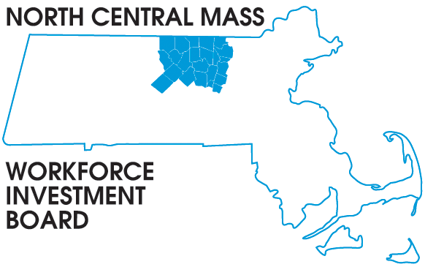
1355 Central Street Leominster, MA 01453 Phone: (978) 534 1023 Fax: (978) 534 1807

BOARD OF DIRECTORS MEETING

Tuesday, June 9, 2015

North Central Chamber of Commerce
860 South Street Fitchburg, MA
8:00 a.m. – 9:30 a.m.

AGENDA

Welcome & Introductions
Welcome new member Roy Nascimento, North Central Chamber President & CEO

Approve Minutes of the March 17, 2015 meeting (Vote required)

Executive Committee report Martha Chiarchiaro (Vote required)
Finance report Barbara Mahoney

Election of Officers (Vote required)

Award presentation to: Don Lowe for his years of service

WIOA Youth RFP update Mary Chase

Grant Updates
DEI-V Theresa Kane
Connecting Activities Conference & STC proposal Mike Gerry

Directors Report: NAWDP presentation, NEG Sector grant, WIOA implementation & Workforce in the NEWS

Other Business

